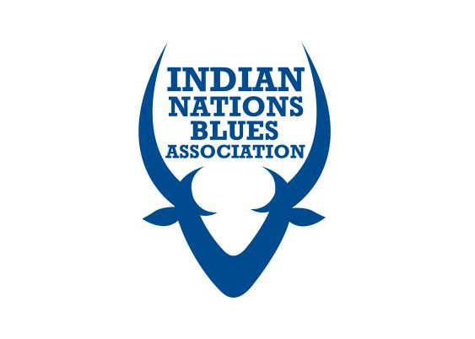

Join the Indian Nations Blues Association
Please consider donating to and /or joining the Indian Nations Blues Association (“INBA”). Your generous donation will fund concerts, workshops and scholarships. The INBA places a special emphasis on outreach to Native American Communities.
For more information go to: www.IndianNationsBluesAssociation.com

Membership Levels
All memberships will get access to discounts and specials
- Individual - $30
- Lifetime Membership - $500+
- Additional or one-time donations: $_

Personal Information
Name: * Email: *
Address: City: State: Phone:
Payments: Make checks payable to “Indian Nations Blues Association” Mail to: INBA; 2488 East 81st Street; Suite 2000; Tulsa, OK 74137
*required field

The Indian Nations Blues Association is a 501(c)(3) charitable organization dedicated to sharing the music and message of the blues through education and performance.
The INBA places special emphasis on outreach to Native American Communities.

